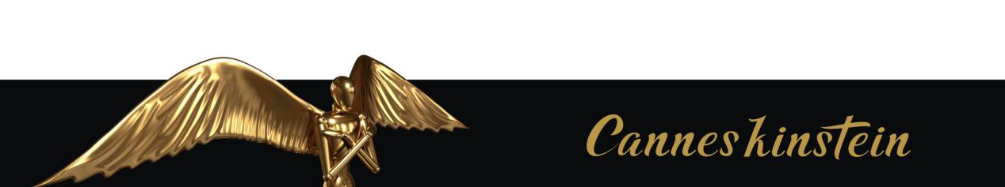

Fill in relevant information / 请使用中文填写
Name / 姓名: |  | Country / 国家:
Contestant / 参赛单位:
Title of Work / 作品名称:
E-mail / 电子邮箱: | Phone / 电话:
Social Media Account / 设计组别:
Address / 联系地址:

Related Statement
1. The organizers and organizers of the competition shall enjoy the right to display, print and publicize the entries;
2. In accordance with the requirements of intellectual property rights protection for innovative and creative works, the participant's participation in the prize means that He/she undertakes to have full, complete and independent intellectual property rights over the entry and not to infringe upon the intellectual property rights of any other person;
3. The organizing committee has the right to disqualify him/her from the competition in case of any intellectual property rights, copyright disputes, etc. , and the contestants will suffer the consequences.

